**autoscaling mechanism using Reinforcement Learning (RL)**

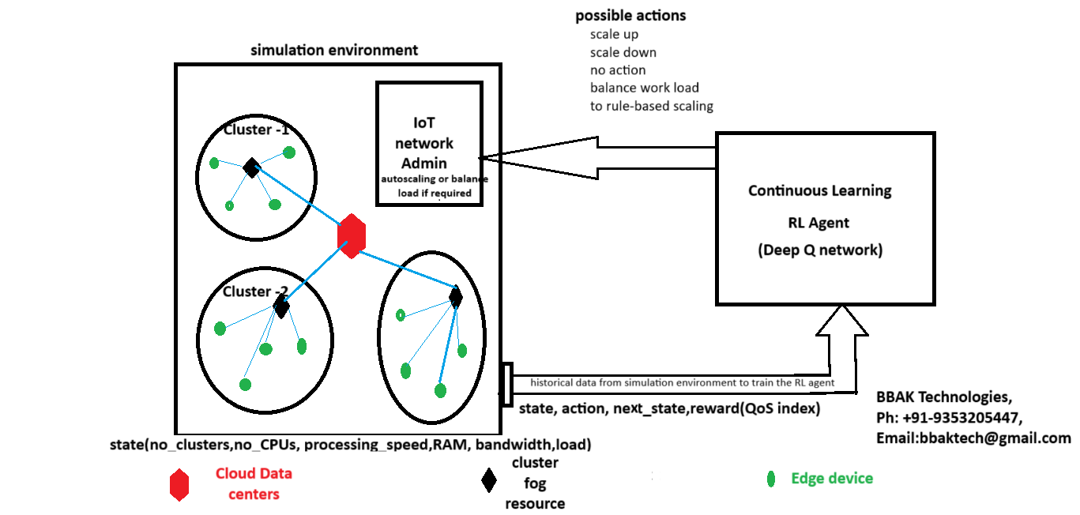

**Implementing an autoscaling mechanism using Reinforcement Learning (RL) to automatically** adjust resource allocation **based on** workload metrics **is a sophisticated approach that can optimize** resource utilization, minimize costs, **and ensure that the system meets** performance requirements **under varying workloads.**

1. **Input(state)**

* work load at clusters (work load is number of edges at clusters, rate at which each edge generates and uploaded tasks)
* number of clusters
* capacity and CPU speed of fog nodes at clusters,
* network bandwidth
* Representation of the system's current status, including resource utilization, latency, workload metrics, and system health.

1. **Action:**

IoT network could be is adjusted (**Autoscaling Targets -** fog server, CPU and capacity, memory, bandwidth, number of clusters)

* **Scale Up:** Add more resources (increase clusters, bandwidth, CPU speed, cores etc.) to handle increased workload.
* **Scale Down**: Remove underutilized resources (decrees clusters, bandwidth, CPU speed, cores etc.).
* **Migrate:** Move workloads between nodes to balance load or reduce latency.
* **Do Nothing**: Maintain current resource allocation.
* **Action**: Possible actions include scaling up, scaling down, migrating tasks, or maintaining the current state.

1. **Reward/Penalty**: A feedback signal to the Reinforcement Learning agent from IoT network, which can be based on system performance (e.g., reduced latency, minimized cost) and penalty for not meeting QoS.
2. **objective:**

* Minimize response time and ensure QoS.
* Optimize resource usage to reduce costs.
* Handle workload fluctuations effectively

1. **Workload Metrics**: Metrics such as CPU usage, memory usage, response time, number of requests (work load), network latency, etc.
2. **Simulation components.**

* **Simulation Environment**: The cloud-fog-edge infrastructure where resources need to be managed. Environment sends feedback signal (**reward/** **penalty**) to the RL agent, which can be based on system performance (e.g., reduced latency, minimized cost) and penalty for not meeting QoS.
* **Cluster Fog Nodes**
* **Edge Devices**
* **Link**
* **IoT Admin**
* **RL Agent**: The core of the predictive autoscaling mechanism that learns optimal scaling decisions based on current states and rewards. Implement monitoring agents to collect data from simulated environment on workload metrics (e.g., CPU, memory usage), system state, response time, and other key performance indicators.

1. **State Representation:**

* Current CPU/memory utilization.
* Incoming workload per slot
* Average response time or latency.
* Previous scaling actions.

1. **Reward Function Design**

Positive reward for meeting response time targets or minimizing costs.

Negative reward for QoS violations, high latency, or excessive resource usage.

1. **Reinforcement learning Algorithm Selection**

Deep Q-Networks (DQN)for discrete actions.

1. **Training the RL Agent**

Input from simulation environment is used by RL agent.

Implement the training loop:

* The agent observes the current state.
* Selects an action based on a DQN
* Receives a reward based on the action suggested by environment.
* Updates the policy to maximize cumulative rewards.

1. **Continuous Learning and Adaptation:**

* Implement Continuous learning to adapt the RL model as new data becomes available.
* Continuously monitor the performance of the autoscaling mechanism and retrain the model periodically to adapt to new patterns or changes in the workload.

1. **Testing:**

* Test the RL-based auto scaler under various scenarios, such as sudden spikes in workload or resource failures.
* Use metrics like average response time, resource utilization, SLA compliance rate, and cost savings to evaluate performance.

1. **Optimization**

* Fine-tune the reward function to balance between minimizing cost and maximizing QoS.
* Adjust state and action spaces based on observed performance to improve decision quality.